INTERNSHIP / UDP / TRAINING REPORT – REPORTING 3
(Advanced Implementation, Testing & Validation Progress Report)
1. Student Information
Student Name | DHRUVI MALANKIYA
Enrollment Number | 23SE02CE056
Program/Branch | B.TECH / COMPUTER ENGINEERING
Semester | 7th
Contact Number | 9313779161
Email ID | 23se02ce056@ppsu.ac.in

2. Internship / UDP / Training Details
Type | INTERNSHIP
Company/Organization | DURVASA INFOTECH
Department/Domain | PYTHON DATA SCIENCE
Mentor Name (Company) | DARSHAN CHAUHAN
Mentor Name (Institute) | Dr. JAYSHRI PATIL
Start Date | 01/06/2026
End Date | 15/10/2026

3. Work Progress Summary
- Project Title:
Smart Healthcare Analytics System

b) Brief Overview of Work Completed After Reporting 2
At the time of Reporting 2, the frontend of the Smart Healthcare Analytics System was completed, but the entire application was running on temporary dummy data, and the backend, database and AI prediction modules were still pending. After Reporting 2, the complete server side development of the project has been carried out, and the application has been successfully converted into a fully working full-stack system. The backend has been developed using Node.js and Express.js, MongoDB has been integrated using Mongoose for permanent data storage, and a separate machine learning service has been developed in Python using FastAPI to serve a trained Random Forest model for diabetes risk prediction. All the temporary dummy data used earlier in the frontend has now been replaced with real data fetched from the backend APIs.
- Major tasks completed: Backend server development using Node.js and Express.js, MongoDB database integration using Mongoose, JWT based user authentication and authorization, development of the Python FastAPI machine learning service, connection of the backend with the machine learning service, replacement of frontend dummy data with real API data, and development of a database seeder for demonstration data.
- Modules completed: Authentication module with registration, login, forgot password and reset password. Health Records module with create, read, update and delete operations. Risk Assessment module with machine learning based diabetes prediction. Daily Planner module with task management and streak calculation. Health Profile module. Reports module with weekly and monthly report generation and PDF export. Dashboard module with aggregated health statistics.
- New features implemented: Machine learning based diabetes risk prediction using a Random Forest classifier, storage of prediction history in the database, JWT token based session management with a validity of seven days, password encryption using bcryptjs, password reset using a secure random token with fifteen minute expiry, rate limiting to prevent brute force attacks, server side input validation, profile photo upload facility, PDF export of health reports, and automatic calculation of health score and activity streak.
- Research / development work completed: The Pima Indians Diabetes Dataset containing 768 patient records with 9 attributes was studied and analyzed, in which 500 records belong to the non-diabetic class and 268 records belong to the diabetic class. Medically implausible zero values present in the Glucose, Blood Pressure, Skin Thickness, Insulin and BMI columns were identified and handled. A Scikit-Learn pipeline was prepared using a custom transformer, median imputation and standard scaling. A Logistic Regression model was trained as a baseline model and a Random Forest classifier was trained as the final model, and both the models were evaluated using accuracy, precision, recall, F1-score, ROC-AUC and confusion matrix. The Random Forest model was selected as the final model and the trained pipeline was saved in joblib format for serving through the API.
- Integration work completed: The React frontend has been connected to the Express backend through a centralized API service file containing 27 API methods. The Express backend has been connected to the Python FastAPI service using HTTP requests with a timeout mechanism. MongoDB has been connected to the backend using Mongoose. Twelve out of thirteen dashboard pages now display live data fetched from the database. The complete data flow from the React user interface to the Express server, then to the FastAPI machine learning service and finally to the MongoDB database has been tested and verified successfully.

c) Overall Project Completion Status
Component | Status | Completion (%)
Requirement / Analysis | Completed | 100 %
Design | Completed | 95 %
Development | Completed | 92 %
Integration | Completed | 90 %
Testing | In Progress | 60 %
Documentation | In Progress | 75 %
Deployment | In Progress | 20 %
Overall Project Completion: 85 %

4. Advanced Implementation
After Reporting 2, the major implementation work was carried out on the backend server, the database layer, the security layer and the machine learning module, and all these components were then integrated with the existing React frontend.
a) Module / Feature Implementation
Module / Feature | Work Completed | Status
Backend REST API Server | Express.js server developed with 15 route groups and 66 API endpoints, along with global error handling and CORS configuration. | Completed
MongoDB Database Integration | 12 Mongoose schemas created with validation rules, references and automatic timestamps. Database connection established through a separate configuration module. | Completed
JWT Authentication | Token generation, token verification middleware, password encryption using bcryptjs with 10 salt rounds and a 7 day token validity implemented. | Completed
Forgot and Reset Password | Secure 32 byte random reset token generated using the crypto module with 15 minute expiry and single use validation. | Completed
Security Middleware | Rate limiting implemented with 10 requests per 15 minutes on authentication routes and 100 requests per 15 minutes on all API routes. Server side input validation added using express-validator. | Completed
Machine Learning Service | Python FastAPI service developed with 5 endpoints serving a trained Random Forest model for diabetes risk prediction. | Completed
ML Model Training Pipeline | Preprocessing pipeline, baseline Logistic Regression model, final Random Forest model, evaluation report and joblib model export completed. | Completed
Backend to ML Service Integration | Express service layer created to communicate with the FastAPI service using HTTP requests with a 6 second timeout and graceful failure handling. | Completed
Health Records Module | Full create, read, update and delete operations with pagination implemented and connected with the frontend. | Completed
Risk Assessment Module | Diabetes risk prediction generated through the machine learning service and stored in the database as prediction history. | Completed
Daily Planner Module | Task create, read, update and delete operations along with streak calculation and task history implemented. | Completed
Health Profile Module | User health profile with height, weight, blood group, medical history, allergies and daily goals implemented. | Completed
Reports Module | Weekly and monthly health report generation with vitals history and PDF export using jsPDF implemented. | Completed
Dashboard Statistics | Health score calculation, BMI, total records, task completion and activity streak aggregation implemented. | Completed
Frontend and Backend Integration | Centralized API service created with 27 methods in 7 groups. Dummy data replaced with live database data in 12 dashboard pages. | Completed
File Upload Module | Profile photo upload implemented using multer with a 2 MB size limit and image file type filtering. | Completed
Database Seeder | Seeder script developed to generate demonstration data of 4 users, 3 health profiles and 93 health records. | Completed
Automated Test Suite | Unit and integration test cases to be written using Jest and Supertest. | In Progress
Cloud Deployment | Deployment of the frontend application, backend server and MongoDB database on a cloud platform. | In Progress
b) Integration / Development Details
Explain:
- Module integration : All the frontend modules have been integrated with the backend through a single centralized API service file named api.js, which contains 27 API methods divided into 7 groups, namely authAPI, recordsAPI, riskAPI, dailyTasksAPI, healthProfileAPI, dashboardAPI and reportsAPI. A React Context based authentication provider has been implemented, which stores the JWT token, restores the user session on page reload and protects 13 dashboard routes using a protected route component. Out of the total 13 dashboard pages, 12 pages now fetch live data from the backend database.
- API integration, if applicable : A total of 66 REST API endpoints have been developed in the Express backend, out of which 23 endpoints are protected using JWT authentication. During development, the Vite development server has been configured with a proxy so that all the requests beginning with /api are forwarded from port 3000 to the backend server, which avoids cross origin problems. The JWT token is stored in the browser local storage and is automatically attached to every protected request using the Authorization header in Bearer format.
- Database integration : MongoDB has been integrated using Mongoose. A total of 12 schemas have been created, which include User, HealthProfile, HealthRecord, DailyTask, PredictionHistory, Patient, Doctor, Appointment, Department, Invoice, Medicine and LabTest. All the schemas contain automatic timestamps. Seven secondary indexes have been created, which include six unique indexes and one compound index on the user and task date fields for faster planner queries. Password encryption is performed automatically inside a pre-save hook of the User schema, and the BMI value is calculated automatically inside a pre-save hook of the Health Record schema.
- Hardware integration, if applicable : Not applicable, as the project is a web based software application and does not use any external hardware device or sensor.
- Software integration : The system has been integrated as three independent services running together. The React frontend runs on port 3000, the Node.js and Express backend runs on port 5001, the Python FastAPI machine learning service runs on port 8000, and the MongoDB database server runs on port 27017. A startup script has been prepared which starts the database, the machine learning service, the backend server and the frontend application in the correct sequence, and also performs a warm-up request on the machine learning model so that the first prediction requested by the user is not delayed.
- Major coding / development work : Approximately 3,454 new lines of code have been written after Reporting 2, which include 3,019 lines of backend JavaScript code across 40 files and 435 lines of Python code for the machine learning service. The backend contains 5 controller files, 15 route files, 12 model files and 4 middleware files. The machine learning module contains a preprocessing module, a training module, a prediction module and an API module. The trained model file is 908,699 bytes in size and is loaded once into memory when the service starts.
c) Final / Updated Architecture
The updated system architecture of the Smart Healthcare Analytics System after the backend, database and machine learning integration is given below.
Diagram:
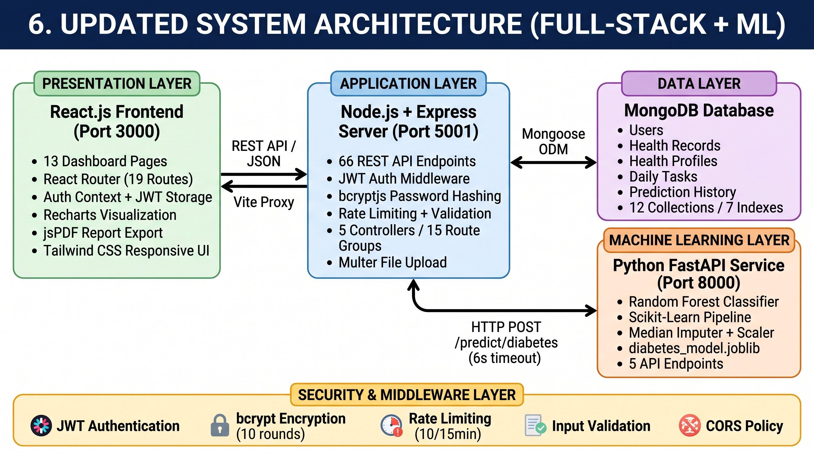
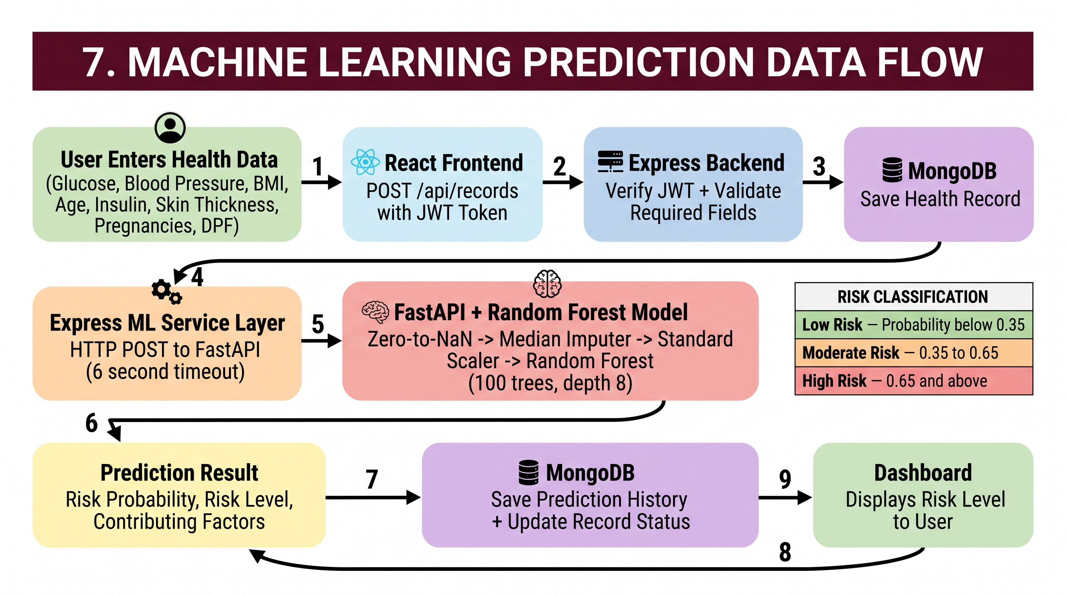
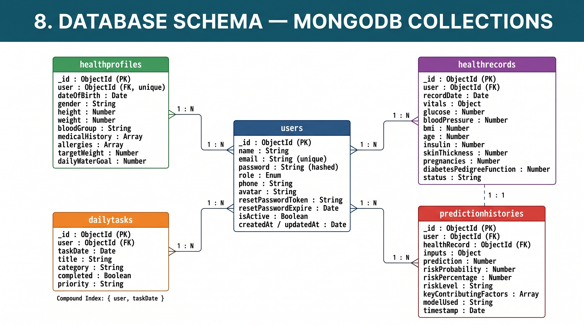
Brief Explanation:
The Smart Healthcare Analytics System follows a three tier architecture consisting of a presentation layer, an application layer and a data layer, along with a separate machine learning service layer. The presentation layer is developed using React.js and communicates with the application layer through REST API calls. The application layer is developed using Node.js and Express.js and is responsible for authentication, request validation, business logic, database operations and communication with the machine learning service. The data layer uses MongoDB for permanent storage of user data, health records, daily tasks, health profiles and prediction history.
The machine learning service has been developed as a separate microservice using Python and FastAPI. When a user submits a new health record, the Express server first stores the record in MongoDB, then sends the clinical parameters to the FastAPI service, which loads the trained Random Forest pipeline and returns the risk probability, the risk level and the key contributing factors. The Express server then updates the status of the health record and stores the complete prediction result in the prediction history collection. This microservice based design keeps the Python machine learning code completely separate from the JavaScript backend code, and allows the main application to continue working normally even if the machine learning service is temporarily unavailable.
The database schema of the system is also shown above. The users collection is the central collection of the database, and the health profiles, health records, daily tasks and prediction history collections are linked with it through a one to many relationship using the user reference field. Each prediction history document is additionally linked with the health record for which the prediction was generated, which allows the complete history of every risk assessment to be traced back to the health record that produced it.
5. Testing and Validation
After completing the backend development, the database integration and the machine learning implementation, functional testing, integration testing, system testing and performance testing were carried out on the complete application. Each API endpoint was tested individually and the complete data flow of the system was verified. The important test cases and their results are given in the following table.
Testing Performed
Test No. | Test / Function | Expected Result | Actual Result | Status
1 | User login with valid credentials | JWT token should be generated and returned | Status 200 received with a valid JWT token in 158 ms | Pass
2 | User login with invalid password | Login should be rejected | Status 401 received with message Invalid credentials | Pass
3 | Access protected route without token | Access should be denied | Status 401 received with message Not authorized, no token | Pass
4 | Access protected route with valid token | Health records of the logged in user should be returned | Status 200 received with 20 records and pagination showing total 31 records in 2 pages | Pass
5 | Access protected route with tampered token | Access should be denied | Status 401 received with message Not authorized, token failed | Pass
6 | Create health record and generate ML prediction | Record should be saved and diabetes risk should be predicted | Status 201 received, risk level High Risk with 71.4 percent probability generated and stored | Pass
7 | Create health record with missing clinical fields | Request should be rejected | Status 400 received with message listing the required fields | Pass
8 | Store prediction history in database | Prediction record should be saved with input values and result | Prediction history entry created successfully with all input parameters and output values | Pass
9 | User registration with weak password | Registration should be rejected | Status 400 received with message Password must be at least 8 characters | Pass
10 | User registration with duplicate email | Registration should be rejected | Status 400 received with message User already exists | Pass
11 | Rate limiting on login route | Requests should be blocked after 10 attempts | Attempts 1 to 10 returned status 401 and attempt 11 onwards returned status 429 with message Too many attempts | Pass
12 | Forgot password token generation | A secure reset token should be generated | 64 character hexadecimal token generated with 15 minute expiry | Pass
13 | Reset password using valid token | Password should be updated successfully | Status 200 received and login with the new password returned status 200 | Pass
14 | Login using old password after reset | Login should fail | Status 401 received with message Invalid credentials | Pass
15 | Reuse of the same reset token | Request should be rejected | Status 400 received with message Invalid or expired reset token | Pass
16 | Dashboard statistics aggregation | Health score and health summary should be calculated | Status 200 received with health score 78 and 13 calculated statistics fields | Pass
17 | Weekly and monthly report generation | Reports with summary and breakdown should be returned | Status 200 received with period, summary, daily breakdown and weekly breakdown | Pass
18 | Machine learning service health check | Service should respond as healthy | Status 200 received with response indicating the diabetes ML API is healthy | Pass
Testing Methods Used
- Functional Testing : Each module of the application was tested individually by running the application on the local development server, and the output of every feature such as login, registration, health record management, risk prediction, daily planner and report generation was verified.
- Unit Testing : Automated unit test cases were not written in this phase. Unit testing of the backend API functions using Jest and Supertest is planned before Reporting 4.
- Integration Testing : The complete data flow from the React frontend to the Express backend, then to the Python FastAPI machine learning service, and finally to the MongoDB database was tested and verified successfully.
- System Testing : All the four services, namely the MongoDB database server, the machine learning service, the backend server and the frontend application, were started together and the complete system was tested from end to end.
- Performance Testing : The average response time of every API endpoint was measured over multiple requests, and the response time of the machine learning prediction and of the complete request cycle was also recorded.
- User Testing : Formal user testing was not conducted in this phase, as the application is currently running in the local development environment. It is planned after cloud deployment.
- Experimental Validation : The machine learning model was validated experimentally using a stratified train and test split, and its performance was compared against a baseline Logistic Regression model using five evaluation metrics and a confusion matrix.
The testing methods applicable to the present phase of the project are Functional Testing, Integration Testing, System Testing, Performance Testing and Experimental Validation.
6. Results and Performance Analysis
The results obtained after completing the backend development, the database integration and the machine learning implementation are presented below.
a) Final / Updated Results
The Smart Healthcare Analytics System has been successfully converted from a frontend only application into a complete working full-stack application. All the modules which were marked as In Progress in Reporting 2, namely backend development, MongoDB integration and frontend to backend integration, have now been completed and verified. The application now stores all the user data permanently in the MongoDB database and generates disease risk predictions using an actual trained machine learning model.
The machine learning model was trained on the Pima Indians Diabetes Dataset containing 768 patient records with 9 attributes, in which 500 records belong to the non-diabetic class and 268 records belong to the diabetic class. A stratified train and test split of 80 percent and 20 percent was applied with a fixed random state of 42, which resulted in 614 training samples and 154 testing samples. A Logistic Regression model was trained as a baseline model, and a Random Forest classifier was trained as the final model using 100 estimators and a maximum tree depth of 8.
On the test data, the Random Forest model achieved an accuracy of 74.68 percent, a precision of 68.29 percent, a recall of 51.85 percent, an F1-score of 58.95 percent and an ROC-AUC score of 81.70 percent. The baseline Logistic Regression model achieved an accuracy of 70.78 percent, a precision of 60.00 percent, a recall of 50.00 percent, an F1-score of 54.55 percent and an ROC-AUC score of 81.30 percent. The confusion matrix obtained for the Random Forest model on the 154 test samples contains 87 true negatives, 13 false positives, 26 false negatives and 28 true positives. The Random Forest model was selected as the final model because it produced better results than the baseline model in all the five evaluation metrics.
The feature importance analysis of the Random Forest model shows that Glucose is the most influential attribute with an importance of 33.20 percent, followed by BMI with 17.26 percent, Age with 11.10 percent, Diabetes Pedigree Function with 10.35 percent, Insulin with 8.87 percent, Pregnancies with 7.26 percent, Blood Pressure with 6.02 percent and Skin Thickness with 5.94 percent. The three most important attributes together contribute 61.56 percent of the total importance, which matches the medical understanding of diabetes risk factors.
The prediction output of the model is classified into three risk levels. A predicted probability below 0.35 is classified as Low Risk, a probability between 0.35 and 0.65 is classified as Moderate Risk, and a probability of 0.65 and above is classified as High Risk. Along with the risk level, the system also returns the key contributing factors and a medical disclaimer stating that the result is generated for educational purposes only and must not be treated as a medical diagnosis.
A total of 18 functional and integration test cases were executed on the completed system and all of them passed successfully. The average response time of the backend API endpoints was measured between 1 millisecond and 11 milliseconds, the machine learning prediction service responded in an average of 13.3 milliseconds, and the complete request cycle from the frontend to the backend, then to the machine learning service and finally to the database, was completed within 13 to 30 milliseconds.
b) Performance Results
Parameter / Metric | Result Obtained | Expected / Target | Status
1. Model Accuracy (Random Forest) | 74.68 % | Above 70 % | Achieved
2. Model ROC-AUC Score | 81.70 % | Above 75 % | Achieved
3. Model Precision | 68.29 % | Above 65 % | Achieved
4. Average API response time | 1 ms to 11 ms | Below 200 ms | Achieved
5. ML prediction response time | 13.3 ms | Below 500 ms | Achieved
6. Complete request cycle (Frontend to Backend to ML Service to Database) | 13 ms to 30 ms | Below 1000 ms | Achieved
7. Dashboard statistics API response time | 10.7 ms | Below 200 ms | Achieved
8. Health records API response time (20 records per page) | 6.7 ms | Below 200 ms | Achieved
9. Total API endpoints developed | 66 endpoints | Minimum 40 endpoints | Achieved
10. Database collections created | 12 collections | As per design | Achieved
11. Functional and integration test cases passed | 18 out of 18 | 100 percent pass | Achieved
12. Unauthorized access prevention tests passed | 5 out of 5 | 100 percent blocked | Achieved
13. Brute force protection on login route | Blocked after 10 attempts | Within 15 minutes | Achieved
c) Output / Result Screenshots
Screenshot 1: Dashboard with Live Database Data
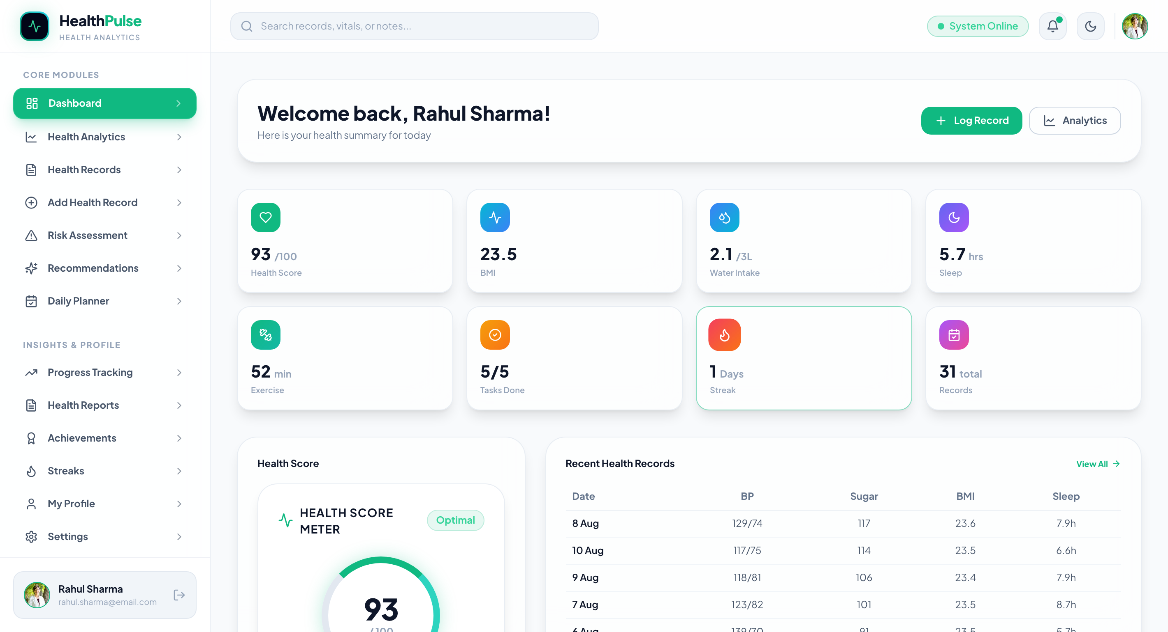
Description:
The Dashboard page now displays live data fetched from the MongoDB database instead of the dummy data used in Reporting 2. The health score, BMI value, total health records, daily task completion and activity streak shown on this page are calculated by the backend aggregation API from the actual health records stored in the database for the logged in user.
Screenshot 2: Risk Assessment with Machine Learning Prediction
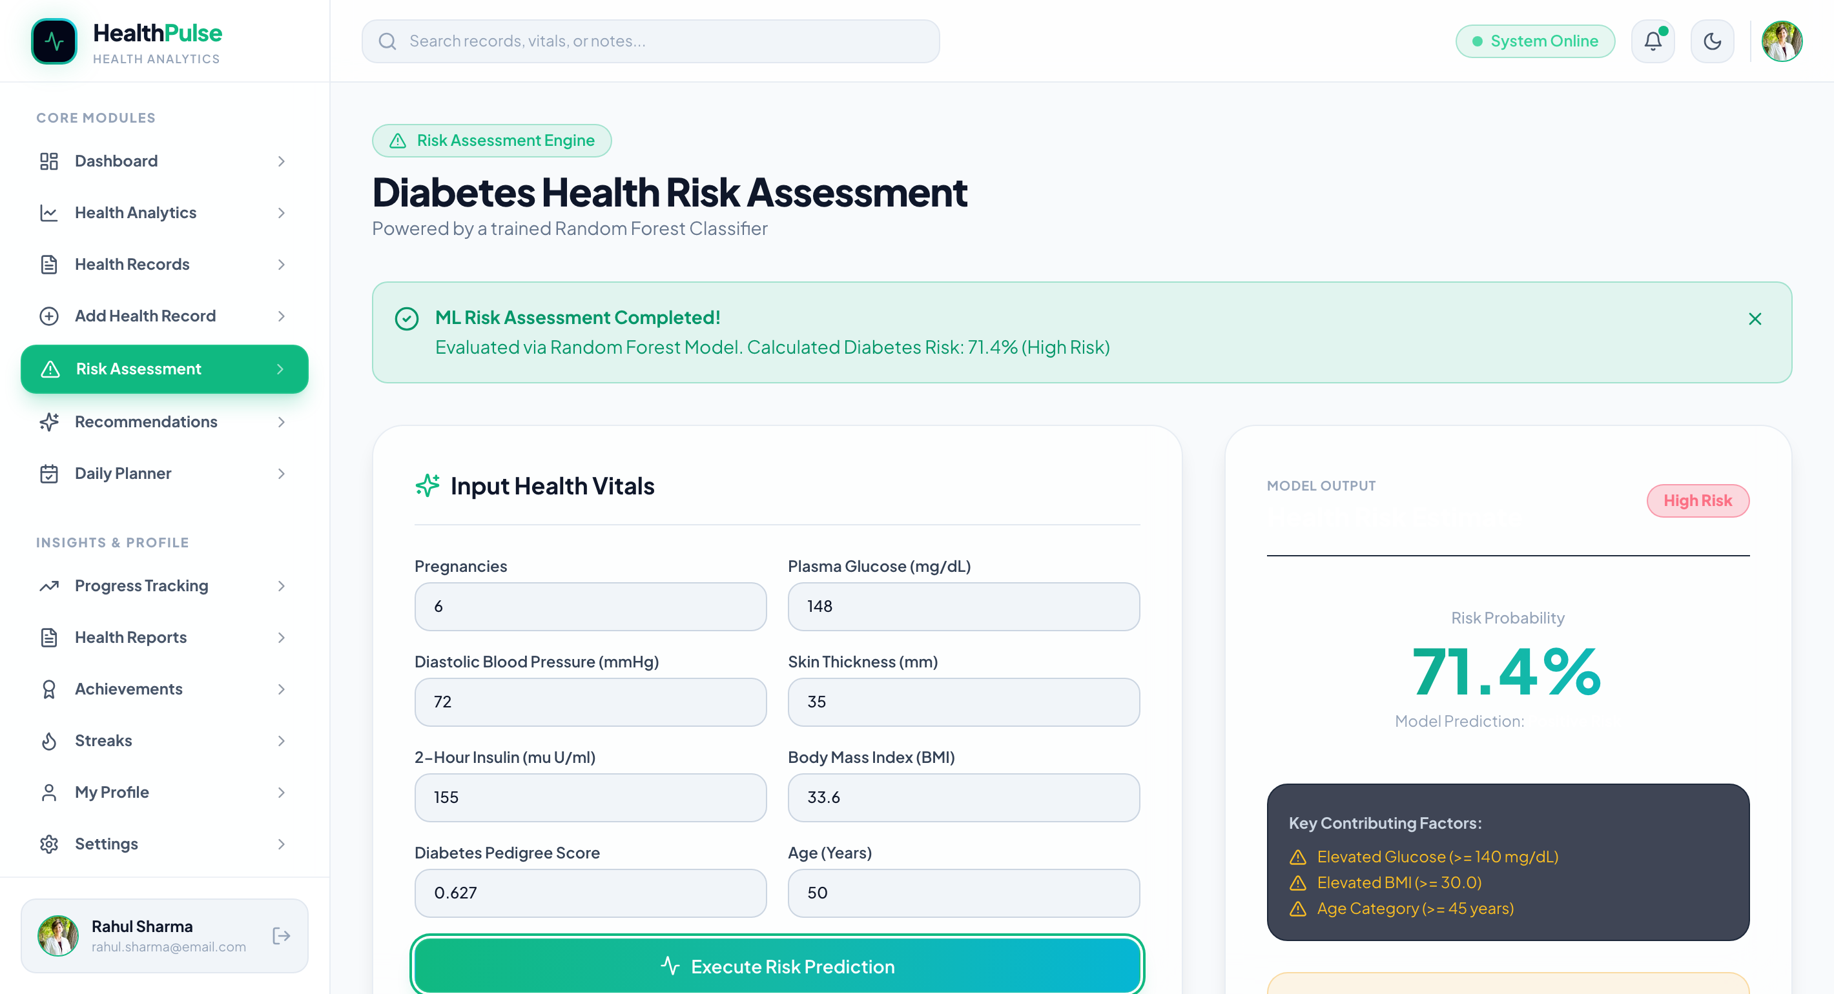
Description:
The Risk Assessment page shows the output of the machine learning module. When the clinical parameters are submitted, the request travels from the React frontend to the Express backend, and then to the Python FastAPI service, where the trained Random Forest model generates the prediction. The page displays the predicted risk level, the risk percentage and the key contributing factors returned by the model, along with the medical disclaimer.
Screenshot 3: Health Records with Database Operations
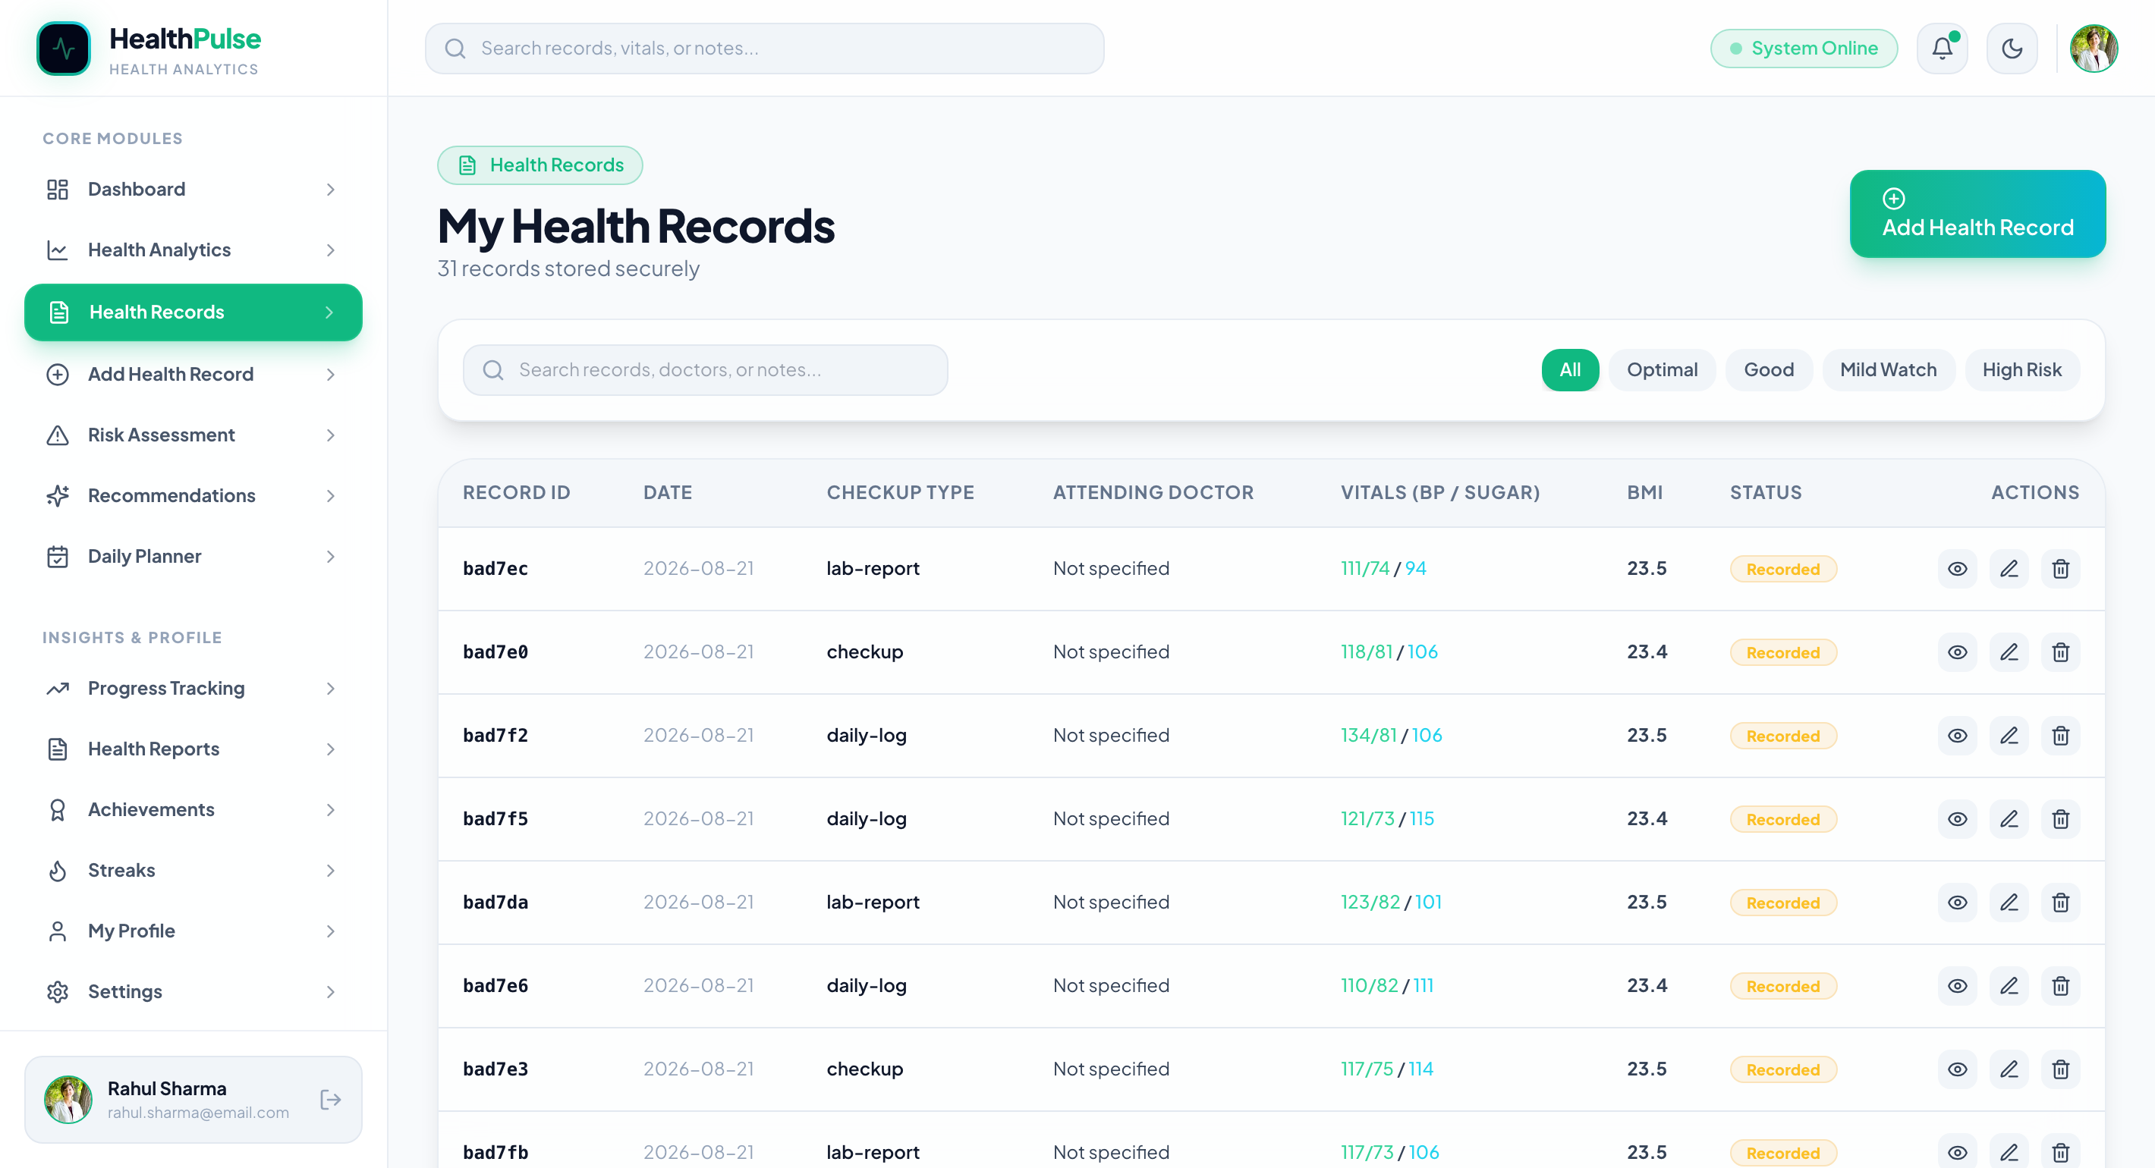
Description:
The Health Records page displays all the health records of the logged in user fetched from the MongoDB database with pagination support. The create, read, update and delete operations on this page are performed through the protected REST API endpoints of the backend server, and every request is authenticated using the JWT token.
All the screenshots given above have been captured from the actual working application running on the local development environment with live data stored in the MongoDB database.

7. Challenges, Solutions and Improvements
Several technical problems were faced after Reporting 2, mainly during the integration of the Python machine learning model with the JavaScript backend and during the replacement of dummy data with real database data. The important problems faced and the solutions applied are given in the following table.
Challenge / Problem | Solution Implemented | Final Outcome
1. Connecting a Python based machine learning model with a JavaScript backend, as both use completely different runtimes. | The machine learning model was deployed as a separate FastAPI microservice, and the Express backend was made to communicate with it through HTTP requests using a dedicated service layer. | The machine learning model is now successfully served to the application, and both the technologies work together without any dependency conflict.
2. The application became unresponsive when the machine learning service was not running. | A 6 second timeout was implemented using an abort controller in the backend service layer, along with error handling which saves the health record and returns a proper message even when the prediction fails. | The application now continues to work normally and stores the health record even if the machine learning service is temporarily unavailable.
3. The first prediction request was taking a long time because the trained model file is loaded into memory only on the first call. | A startup script was prepared which sends one warm-up request to the machine learning service immediately after starting it, so that the model is already loaded in memory before the user makes any request. | The first prediction requested by the user is now served within a few milliseconds instead of taking several seconds.
4. Replacing the dummy data used in the frontend with real database data across all the dashboard pages. | A centralized API service file was created containing all the API methods, and each page was updated one by one to fetch data using React hooks with proper loading and error states. | Twelve out of thirteen dashboard pages now display live data fetched from the MongoDB database.
5. Protecting the application against brute force login attempts and invalid input data. | Rate limiting was implemented using express-rate-limit with separate limits for the authentication routes and the general API routes, and server side validation was added using express-validator. | Login attempts are now blocked after 10 failed tries within 15 minutes, and all the invalid input is rejected before reaching the database.
6. Implementing the forgot password feature without an email service. | A secure 32 byte random token was generated using the Node.js crypto module with a 15 minute expiry, and the token is returned in the API response for demonstration purposes. | The complete password reset flow works correctly, and the token expires after 15 minutes and cannot be used twice.
7. Zero values present in the dataset for the Glucose, Blood Pressure, Skin Thickness, Insulin and BMI columns, which are medically impossible and were reducing the model accuracy. | A custom Scikit-Learn transformer was written to convert these invalid zero values into missing values, followed by median imputation fitted only on the training data to avoid data leakage. | The data quality improved and the final Random Forest model achieved an accuracy of 74.68 percent and an ROC-AUC score of 81.70 percent.
8. Testing the complete system required starting four different services in the correct sequence every time. | A startup script was prepared which starts the MongoDB service, the machine learning service, the backend server and the frontend application in sequence, and checks the health of each service before starting the next one. | The complete system can now be started using a single command, which saves time during development and testing.

Improvements Made After Reporting 2
- The application has been changed from a static frontend application into a complete data driven full-stack application. All the user data is now stored permanently in the MongoDB database instead of being lost when the page is refreshed.
Security of the application has been improved by adding password encryption using bcryptjs, JWT based authentication, rate limiting on the login and registration routes, and server side input validation on all the incoming requests.
- The disease risk prediction, which was only a static user interface in Reporting 2, is now generated by an actual trained Random Forest machine learning model, and every prediction is stored in the database as prediction history.
Database query performance has been improved by creating seven indexes, and pagination has been implemented in the Health Records module so that large amounts of data can be loaded efficiently.
- A database seeder has been developed which creates demonstration data of 4 users, 3 health profiles and 93 health records, so that the complete application can be demonstrated with meaningful data at any time.
A startup script has been prepared which starts all the four services in the correct sequence and also warms up the machine learning model, which has reduced the response time of the first prediction from several seconds to a few milliseconds.
8. Current Project Status

☐ Completed
☑ Mostly Completed
☐ Partially Completed
☐ Work in Progress

Completed Components
Landing page and user interface. User authentication module with registration, login, forgot password and reset password. Backend REST API server with 66 endpoints. MongoDB database integration with 12 collections. JWT based authentication and authorization. Password encryption and security middleware including rate limiting and input validation.
Machine learning model training and evaluation. Python FastAPI machine learning service. Integration of the machine learning service with the backend. Health Records module with full CRUD operations. Risk Assessment module with prediction history. Daily Planner module with streak calculation. Health Profile module. Reports module with PDF export. Dashboard with aggregated statistics. Frontend and backend integration. Database seeder for demonstration data.
Pending Components
Automated unit test cases and integration test cases using Jest and Supertest. Cloud deployment of the frontend application, backend server and MongoDB database. Email service integration for sending the password reset link to the user.
Machine learning models for heart disease and hypertension risk prediction. API documentation using Swagger for the Node.js backend. Final project documentation and user manual.
Work Planned Before Reporting 4
Writing automated test cases for the backend API endpoints and performing complete regression testing. Deploying the frontend application, backend server and MongoDB database on a cloud platform and configuring the environment variables for the production environment. Integrating an email service for the password reset functionality.
Training additional machine learning models for heart disease and hypertension risk prediction and adding them to the existing FastAPI service. Preparing complete API documentation. Performing final system testing on the deployed application and preparing the final project report with all the diagrams, screenshots and results.
9. Learning and Skills Acquired
Technical Skills
Backend development using Node.js and Express.js. Designing and developing REST APIs. Database design and schema creation using MongoDB and Mongoose. Implementation of JWT based authentication and authorization. Password encryption using bcryptjs. Server side input validation and rate limiting. Microservice architecture and communication between two different technology stacks. Machine learning model development using Python and Scikit-Learn. Data preprocessing, handling of missing values and prevention of data leakage. Model evaluation using accuracy, precision, recall, F1-score, ROC-AUC and confusion matrix. Building and serving machine learning APIs using FastAPI. Model serialization using joblib. Integration of a React frontend with backend APIs. Asynchronous programming and error handling in JavaScript. API testing and debugging.
Tools / Technologies Learned
Node.js, Express.js, MongoDB, Mongoose, MongoDB Compass, JSON Web Token, bcryptjs, express-validator, express-rate-limit and multer.
Python, FastAPI, Uvicorn, Scikit-Learn, Pandas, NumPy, joblib, Pydantic, Postman, Visual Studio Code, Git, GitHub, Vite, jsPDF and Swagger UI.
Professional Skills
Analytical thinking and problem solving while integrating two different technology stacks. Time management and task prioritization while completing multiple modules within the given time. Debugging and troubleshooting of backend and integration errors.
Understanding of software architecture and design decisions. Documentation and technical report preparation. Self learning through official documentation and research papers. Communication and regular reporting of progress to the mentor.
Major Learning from Internship / UDP / Training
The most important learning from this phase of the internship was understanding how a real full-stack application is built and connected from end to end. Building the frontend interface alone was not sufficient, and the actual complexity of the project was understood only while developing the backend, designing the database schemas, implementing the security layer and connecting the machine learning model with the web application.
Working with a microservice architecture taught how two completely different technologies such as Node.js and Python can work together in a single system through REST APIs. Training the machine learning model also gave the practical understanding that data preprocessing and correct evaluation are equally important as the choice of the algorithm, and that a model must be evaluated using multiple metrics rather than accuracy alone, especially in healthcare applications where a false negative result is more harmful than a false positive result.
9. References and Resources Used
Minimum 5 genuine references(APA 7th Edition) are mandatory.
Students must mention the resources actually used during the work.
References may include:
- Research papers
- Books
- Official documentation
- Technical websites
- Standards
- APIs / libraries
- Software documentation
References
[1] Smith, J. W., Everhart, J. E., Dickson, W. C., Knowler, W. C., & Johannes, R. S. (1988). Using the ADAP learning algorithm to forecast the onset of diabetes mellitus. Proceedings of the Annual Symposium on Computer Application in Medical Care, 261-265.
[2] Breiman, L. (2001). Random forests. Machine Learning, 45(1), 5-32. https://doi.org/10.1023/A:1010933404324
[3] Pedregosa, F., Varoquaux, G., Gramfort, A., Michel, V., Thirion, B., Grisel, O., Blondel, M., Prettenhofer, P., Weiss, R., Dubourg, V., Vanderplas, J., Passos, A., Cournapeau, D., Brucher, M., Perrot, M., & Duchesnay, E. (2011). Scikit-learn: Machine learning in Python. Journal of Machine Learning Research, 12, 2825-2830.
[4] Jones, M., Bradley, J., & Sakimura, N. (2015). JSON Web Token (JWT) (RFC 7519). Internet Engineering Task Force. https://doi.org/10.17487/RFC7519
[5] Meta Open Source. (2026). React documentation: Describing the UI. https://react.dev/learn (Accessed August 2026)
[6] OpenJS Foundation. (2026). Express 5.x API reference. https://expressjs.com/en/5x/api.html (Accessed August 2026)
[7] MongoDB, Inc. (2026). MongoDB manual: Data modeling and indexes. https://www.mongodb.com/docs/manual/ (Accessed August 2026)
[8] Ramirez, S. (2026). FastAPI documentation: Tutorial and user guide. https://fastapi.tiangolo.com/tutorial/ (Accessed August 2026)
Reference Requirements
- Minimum 5 references
- References must be relevant to the project.
- Sources must actually be used by the student.
- References must be cited wherever required in the report.
- Fake or unrelated references are not acceptable.
- Official documentation and reliable academic sources are preferred.

Evaluation (To be filled by Mentor (Institute))

Criteria | Excellent | Good | Average | Poor | Marks
Work Completion & Implementation (25) | ≥90% meaningful work completed | 75–89% | 50–74% | <50% | /25
Testing, Results & Validation (25) | Strong testing with evidence and analysis | Good testing | Limited testing | No meaningful validation | /25
Technical Understanding (20) | Strong conceptual and technical understanding | Good understanding | Basic understanding | Unable to explain work | /20
Documentation & Progress Presentation (20) | Complete, clear and well documented | Minor gaps | Incomplete documentation | Poor documentation | /20
References & Citations (10) | Relevant, properly cited and formatted | Minor issues | Limited/relevant sources | Missing/improper | /10
TOTAL |  |  |  |  | /100

Evaluation
Student Signature | Mentor (Company)  Signature | Mentor (Institute)  Signature

Mentor (Institute) Remarks
________________________________________________________________________________________________________________________________________________________________________________________________________________________________________________________________________________________________________________________________________________________________________________________________________________________________________________________________________________________________________________________________________________________________________________________________________________________________________________________________________________________________________________________________________________________________________________________________________________________________________________________________________________________________________________________________________________________________________________________________________________________________________________________________________________________________________________________________________________________________________________________________________________________________________________________________________________________________________________________________________________________________________

